**Digital Themometer Using PIC 18f452**

**Project Explanation:**

In this project we have to design the digital therometer using PIC 18f452 and LCD.The ciruit measures the input reading taken from sensor and after that process it and converts the reading into degree centirade and faranhite.After that LCD shows the out in the farnhite as well as in Centigrade.On the 1st line the name of the student is shown.

**Circuit Diagram:**

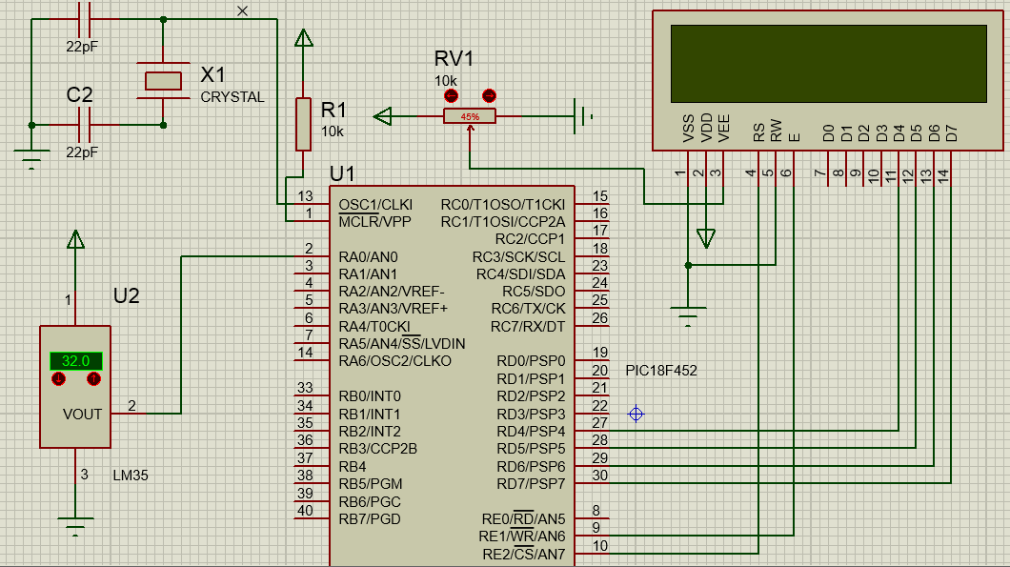

This Circuit diagram shows the connection of PIC 18f452 with the lcd close with the sensor shown as LM35 and crystal oscillators and other small components.The crystal frequency for this project was taken as 32Mhz and capacitors used for this are 22pf capacitors.Initially,thecircuit takes LM35 measures the temperture and converts it in the form of analog electric siganals after that contrller take these pulses and converts reading to Degree centigrade and also in farnhite.After converting it the controller prints the reading on the 2nd line of the lcd.Onthe first line the name of the student is printed.

**Description of the Sensor used:**

LM35 is a precession Integrated circuit Temperature sensor, whose output voltage varies, based on the temperature around it. It is a small and cheap IC which can be used to measure temperature anywhere between -55°C to 150°C. It can easily be interfaced with any Microcontroller that has ADC function or any development platform like Arduino.

Power the IC by applying a regulated voltage like +5V (VS) to the input pin and connected the ground pin to the ground of the circuit. Now, you can measure the temperate in form of voltage as shown below.

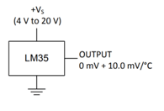

If the temperature is 0°C, then the output voltage will also be 0V. There will be rise of 0.01V (10mV) for every degree Celsius rise in temperature.  The voltage can converted into temperature using the below formulae.

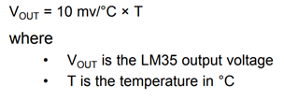

**Block diagram Of Circuit:**

Controller

16x2 Lcd Display

LM35 Sensor

**Code:**

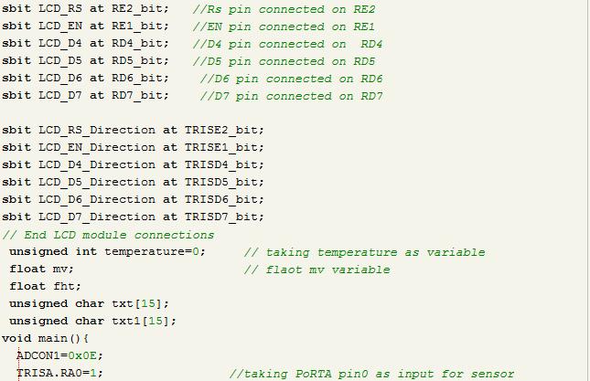

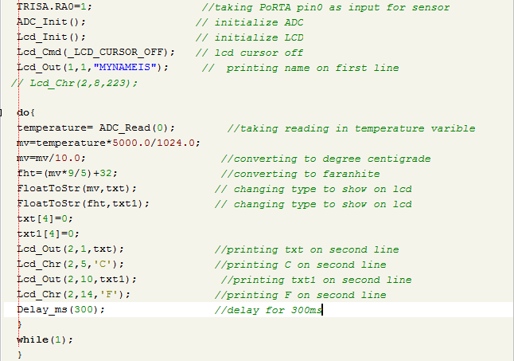

**Explanation how code works:**

**Explanation of I/O ports:**

In the first picture all the initalizations are given.The conections of lcd and pushbutons and motor drive are declared.The data pins of lcd are connected the RD4,RD5,RD6 and RD7 while its control pins are connected to the RE1 and RE2.Similarly the sensor is attached on the RA0 of the PortA.The crystal oscillator along with two 22pf capacitors in also used to give external clock to the microcontroller.

**Explanation of main code:**

Firstly we have started our main by initalizing lcd and ADC after that we have used taken the value from sensor by ADC read functon and saved the value in the varible named as the temperature.so after that we know have multiplied the incoming value by 5000 and divide by 1024 as 1024 is the resolution of the ADC.Then result is saved in the mv variable the mV variable is divided by 10 to change this value in Centigrade.After that to change this value from centigrade to the faranhite we know that

F=C*9/5+32

So by this formula we have changed into faranhite. After that these both reading shown on the second line of the screen as on the first line the Name of the student is printed.For thisproject we have added two libraries which are LCD.h to process and show values on the LCD.Secondly we have added the library amed as the ADC.h which converts the incoming signals from the lm35 and shows uson the lcd .On the last butnot least we have added the library named as the conversion.h which converts thefloat valuesto the string values.All this work is done in the infinte loop so that the sensor keeps taking values and micrcontrollerkeeps process it and the keep showing it on the lcd.In the end we have given the delay of the 300ms so that values could be shown easily on the lcd and then the again loop starts.

**Code Explanation Via Block diagram:**

initalization

while

Print on LCD

Converts in Centigrade

Takes temp input

Converts in Faranhite

Print on LCD